Dashboard Reporting in Report Center
Friday, November 7, 2025

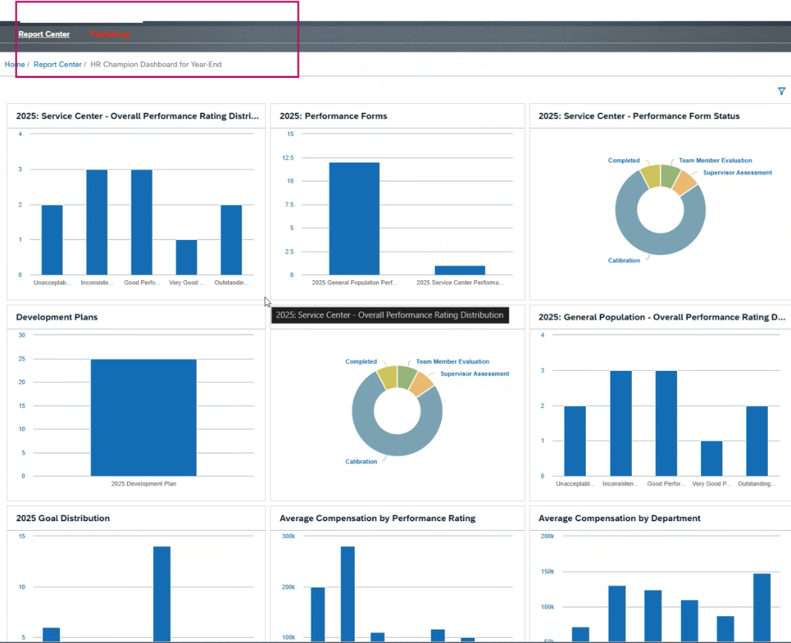

Metrics
Friday, November 7, 2025
1:01 PM

Metrics are created in Provisioning whereas Insights are created in SF Dashboard

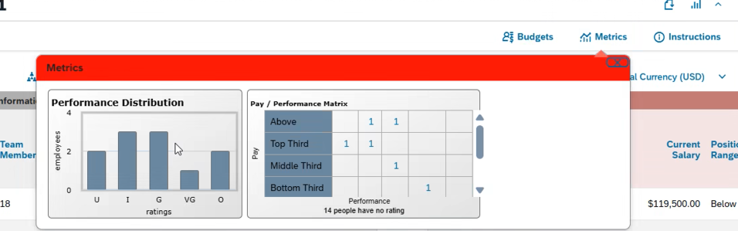

Gender & Ethnicity Diversity Analytics
Friday, November 7, 2025
1:12 PM

Ethnicity Report for US only

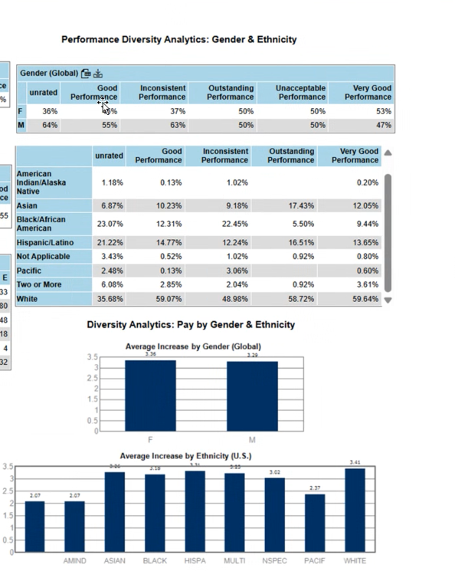

Manage Dashboard
Build Tile
Select a domain :

